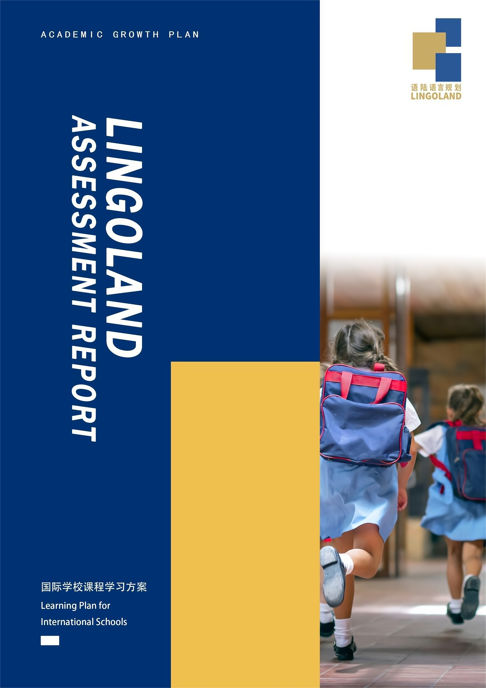

**封面文案标题**

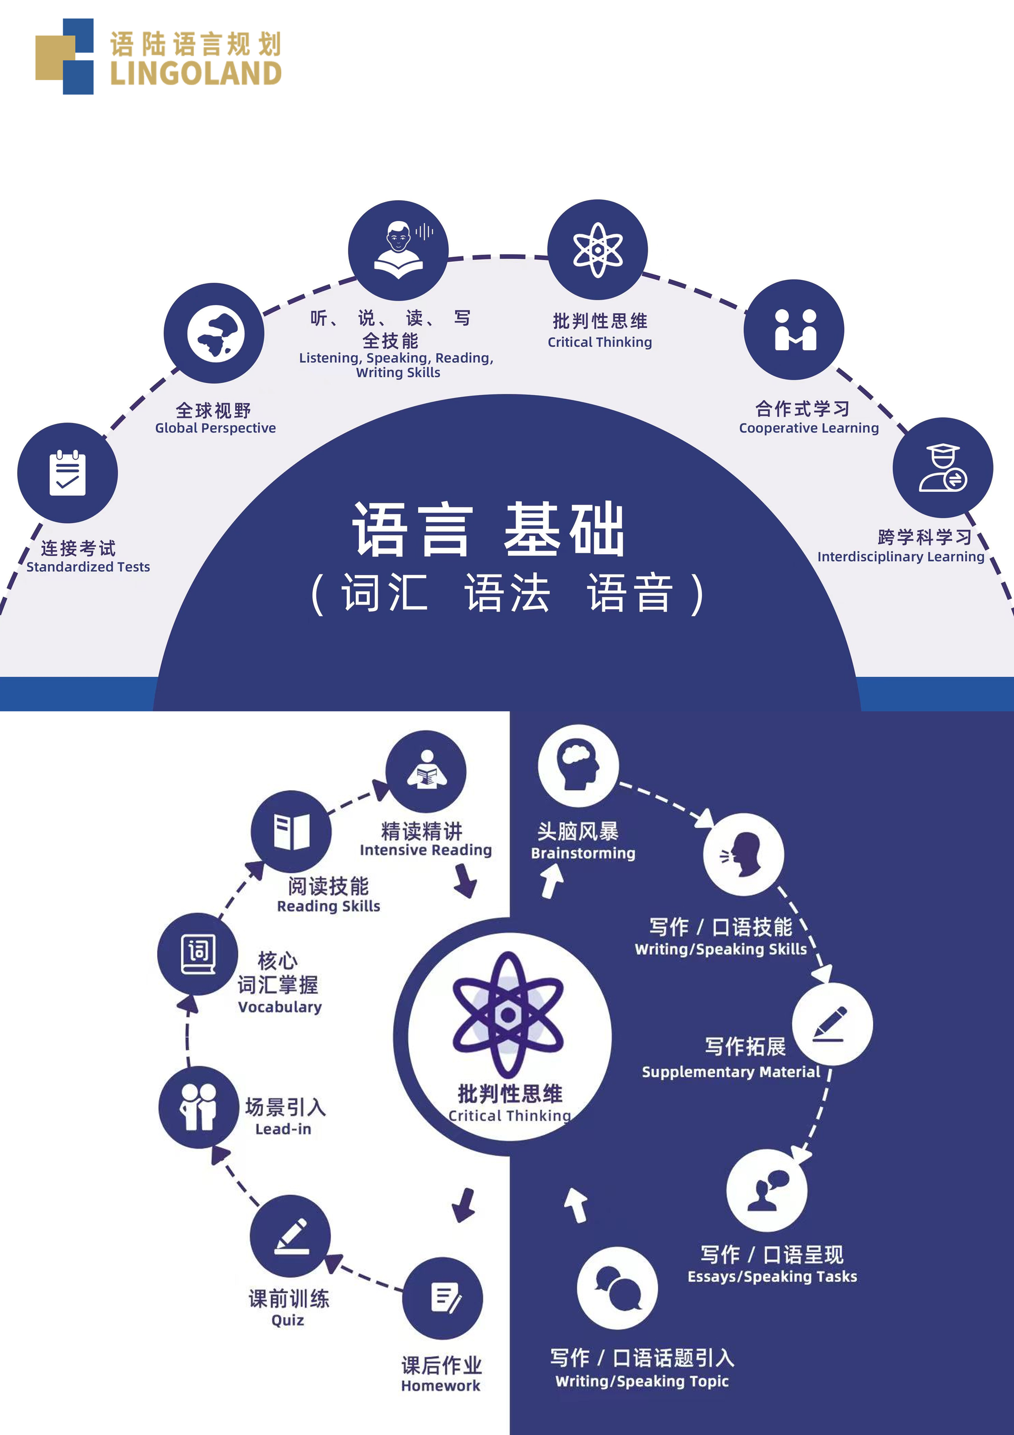

**LINGOLAND国际学校课程学习方案**

一．测评介绍及升学目标分析

听说读写

|  |  |  |  |  |  |  |  |  |  |
| --- | --- | --- | --- | --- | --- | --- | --- | --- | --- |
| Lingoland | 第一梯队国际 | 娃哈哈前20% | TOEFL  Junior | 蓝思值 | 托福 | 剑桥系考试 | CEFR | 词汇量 | 雅思 |
| K | K | G2 |  | 160L |  | Starters | Pre-A1 | 400 |  |
| G1 | G1 | G3 |  | 165L |  | Movers | A1 | 800 |  |
| G2 | G2 | G4 |  | 425L |  | Flyers | A2- | 1100 |  |
| G3 | G3 | G5 | 625 | 600L |  | KET | A2+ | 1500 | 3 |
| G4 | G4 | G6 | 725 | 725L | 31 | PET | B1- | 2500 | 4 |
| G5  **所在年级** | G5 | G7 | 785 | 825L | 45 | PET | B1+ | 3500 | 5 |
| G6 | G6 | G8 | 860 | 925L | 66 | PET | B2- | 4500 | 5.5 |
| G7 | G7 | G9 | 865 | 1000L | 93 | FCE | B2+ | 6000 | 6.5 |
| G8 | G8 | G10 | 900 | 1050L | 101 | FCE | C1- | 7500 | 7 |
| G9 | G9 | G11 |  | 1125L | 109 | CAE | C1+ | 10000 | 7.5 |
| G10 | G10 |  |  | 1175L | 120 | CAE |  | 15000 | 8 |
| G11 | G11 |  |  | 1225L |  |  |  | 17500 |  |
|  | G12 |  |  | 1250L |  |  |  | 20000 |  |

* 测评说明：本次测评难度为KET难度

测评分析

| * 阅读 正确率10/30 低于A1水平 | |
| --- | --- |
| 1. **卷面分析** | * **时间分配：**··································80%   能在规定时间内完成。   * **信息理解：**··································30%   对于文章主要信息很难抓住，在细节理解上受生词影响，也无法依赖语境推测句意。   * **词汇量：**··································30%   基础生活词汇及部分学术词汇掌握不足，阅读中出现多处不认识的关键词，影响理解深度。   * **考试技巧：**··································30%   未明显体现出。不会主动圈划文章中的关键字或者是做笔记。   * **阅读速度：**··································70%   能够在规定时间内完成整篇文章的阅读。   * **阅读策略（扫读，预测，跳读，推理等）：**·······························30%   缺乏阅读策略意识，偏向直译式理解，需进一步训练信息筛选与逻辑推断能力。   * **背景知识：**··································60%   对常见文学/修辞手法、文化及学科性主题了解有限，需积累更多英语语境下的知识。   * **专注力：**··································80%   较为专注。 |
| 1. **成因分析** | * 词汇量不足，特别是生活化与学术类词汇，限制了对细节与隐含信息的把握 * 缺乏系统的阅读策略训练（如预测、扫读、略读、推理），阅读过程偏被动 * 英语阅读输入量有限，导致语篇结构与段落逻辑识别能力较弱 * 语法知识薄弱，遇到长句（例如从句）无法理解句意 * 背景知识储备不足，影响部分材料的理解与延伸思考 |

